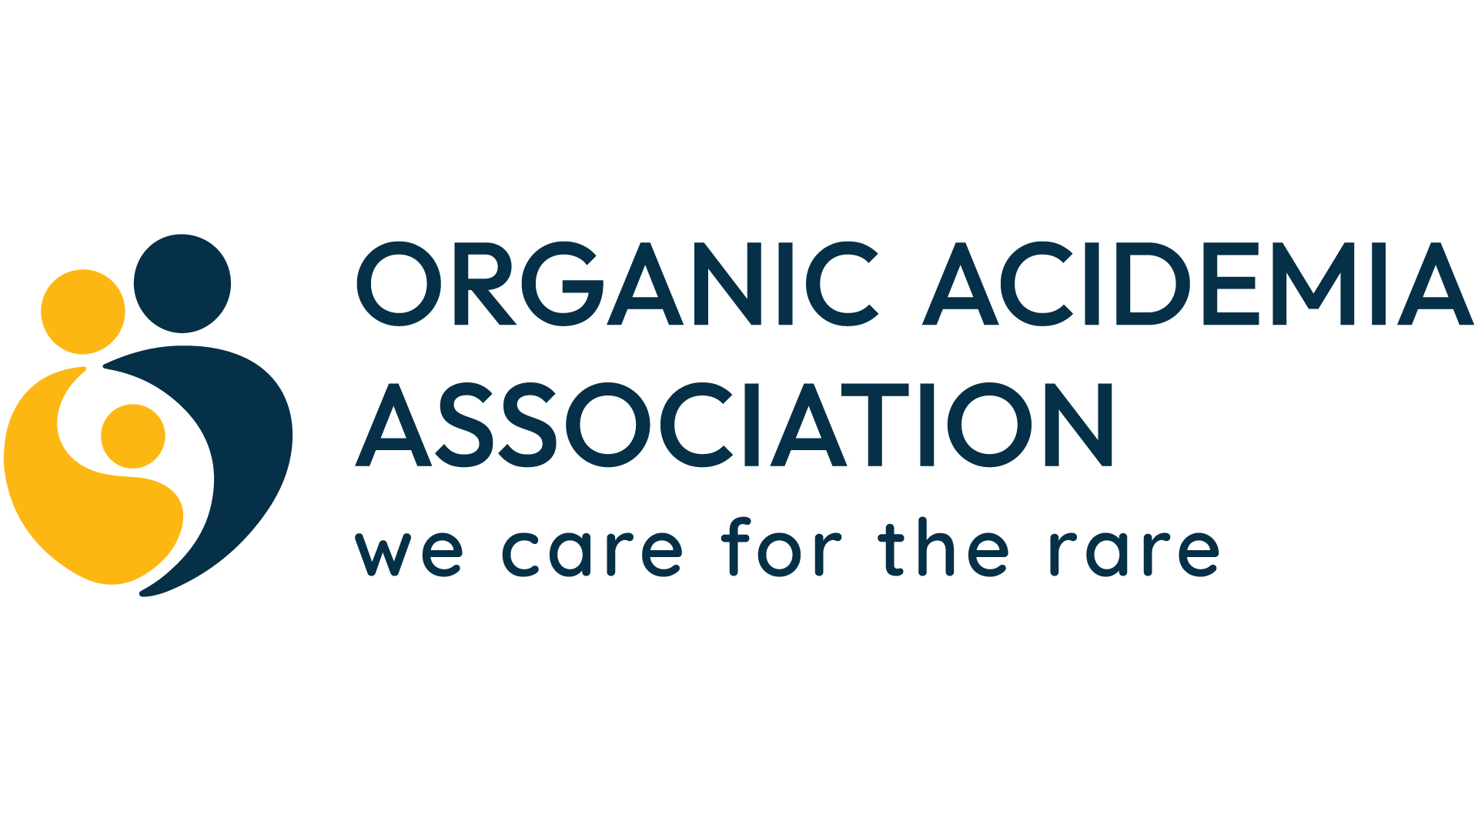
WE CARE FOR RARE

Fundraising for OAA
  - A practical guide for parents, families, and friends

One family. One idea. A community of impact.
Whether you raise $100 at a neighborhood event or invite the entire OAA community to participate, your fundraiser can increase awareness, connect families, and strengthen OAA's work.

Start small. Tell your story. Make it easy to give.
Prepared for the Organic Acidemia Association community

Welcome
Thank you for wanting to raise funds for the Organic Acidemia Association (OAA). Families are OAA's most powerful ambassadors: you understand the daily realities of organic acidemias, and your personal connection helps others understand why support matters.
The easiest place to begin
Choose one simple idea, one clear fundraising goal, and one four- to six-week campaign period. Ask OAA to confirm the details before you publish or collect money in OAA's name.

What your fundraiser can accomplish
- Help OAA provide reliable information and family support.
- Support education, community programs, advocacy, and research-related initiatives.
- Increase awareness of organic acidemias among neighbors, schools, workplaces, and local businesses.
- Give friends and relatives a concrete way to stand beside your family and the broader rare-disease community.

Your quick-start plan
- Choose an idea that fits your time, energy, and support network.
- Contact OAA with the proposed name, date, platform or venue, and fundraising goal.
- Confirm how donations will be collected and acknowledged.
- Create a short, permission-based family story and one strong photo.
- Promote the fundraiser, thank supporters, and send OAA a final summary.

OAA contact
Email: info@oaanews.org | Phone: 763-559-1797 | Website: https://oaanews.org

Choose the Right Fundraiser
A successful fundraiser does not have to be elaborate. The best choice is one your family can enjoy and complete without creating more stress than it solves.
Idea | Best for | Effort | How it raises funds
Birthday or milestone campaign | Fast online outreach | Low | Ask for donations instead of gifts
Restaurant give-back night | Local families and schools | Low-medium | Participating location donates a portion of sales
Walk, roll, or move-a-thon | All ages and abilities | Medium | Registration, pledges, and sponsors
Yard sale or craft sale | Neighborhood participation | Medium | Donate sale proceeds
Trivia, bingo, or game night | Clubs, schools, workplaces | Medium | Tickets, team fees, raffle where legal
Community-wide awareness challenge | OAA families everywhere | Medium-high | Peer-to-peer pages and shared campaign goal
Benefit dinner, golf event, or tournament | Strong volunteer/business network | High | Tickets, sponsorships, auction, donations

Low-lift ideas
- Facebook or other approved social fundraising campaign tied to a birthday, diagnosis anniversary, Rare Disease Day, GivingTuesday, or holiday.
- Employer matching-gift reminder: ask supporters to check whether their employers match charitable gifts.
- In-memory or in-honor campaign for a loved one, teacher, clinician, or special milestone.
- Neighborhood lemonade, cocoa, bake, plant, book, or garage sale.
- Local business round-up campaign or donation jar, with the business's written permission and OAA approval.

Local Fundraising Ideas

Dine-to-donate night
Ask a restaurant to designate a night when a percentage of eligible purchases supports OAA. Give the business OAA's full legal name and ask it to issue proceeds directly to OAA when possible.

Walk, roll, or move for OAA
Create an inclusive route at a park, school track, or indoor mall. Participants can walk, use wheelchairs, ride adapted bikes, or choose their own form of movement.

School or workplace awareness day
Invite participants to wear blue or rare-disease colors and donate. Add a short educational message so the event raises understanding as well as funds.

Community game or trivia night
Partner with a community center, church, club, brewery, or restaurant. Charge a team fee and seek donated prizes. Confirm local rules before offering games of chance.

Sports or hobby fundraiser
Consider a bowling event, golf outing, pickleball tournament, fishing contest, car show, craft workshop, dance class, or youth sports challenge.

Sales with a purpose
Offer handmade items, baked goods, plants, used books, art, or family-designed shirts through a vendor approved by OAA. State clearly whether all proceeds or a defined portion benefits OAA.
Accessibility matters
Choose an accessible venue, describe parking and restroom access, offer seating and quiet space, and provide a participation option for people who cannot attend in person.

Ideas for the Entire OAA Community
A shared campaign works best when OAA provides one theme, timeframe, donation destination, and graphics, while families personalize the message with their own stories.

Rare Disease Day: 28 Days for Rare
During February, invite participants to raise $28, complete 28 acts or miles, or recruit 28 donors. Families can participate from anywhere.

Move for Metabolic Families
A virtual walk-roll-move campaign in which each participant chooses an accessible activity and sets a personal goal.

Birthday Club for OAA
Invite families to create a fundraiser during their child's or adult family member's birthday month, using a common OAA toolkit and hashtag.

One Community, Many Stories
Feature one family story at a time during a defined campaign. Each family shares the central donation link and invites others to pass the story forward.

Research or Family Forum Challenge
Use a specific, OAA-approved need as the campaign focus. A sponsor may offer a matching challenge to create urgency.

Create for Rare
An online art, craft, recipe, photography, or talent showcase with optional entry donations and community voting that does not involve a prize of chance.

What OAA could provide for a shared campaign
- A central donation page and consistent campaign language.
- Editable social graphics, sample posts, email copy, and a printable flyer.
- Guidance for family stories, photo permissions, and privacy.
- A campaign calendar with launch, reminder, matching-gift, and thank-you dates.
- Recognition in OAA communications, with permission.

Plan Your Fundraiser

1. Define the goal
Choose a realistic dollar goal and explain what the campaign supports using language approved by OAA. Unless OAA has established a restricted fund, say the fundraiser will 'benefit OAA' rather than promising that every dollar will be used for one particular project.

2. Ask OAA before launching
- Proposed event or campaign name and short description
- Date, location, and expected audience
- Fundraising platform and how donations will reach OAA
- Any use of OAA's logo, photos, stories, or tax identification information
- Planned sponsors, vendors, prizes, raffles, auctions, or alcohol
- What support you are requesting from OAA

3. Build a simple budget
Item | Estimated | Actual
Venue/permits | $________ | $________
Food/supplies | $________ | $________
Printing/platform fees | $________ | $________
Total expenses | $________ | $________
Gross raised | $________ | $________
Net gift to OAA | $________ | $________

4. Create a promotion calendar
- 4-6 weeks before: announce and invite.
- 2-3 weeks before: share the family story and explain OAA's impact.
- 1 week before: share goal progress and practical details.
- Final 48 hours: make a clear last call.
- Within 1 week after: report the result and thank supporters.

Tell Your Story Safely and Clearly
People give when they understand the person, the need, and the impact. A short, specific story is often more effective than a long medical explanation.

A simple story formula
- Connection: Introduce your family member and your connection to organic acidemia.
- Reality: Share one or two challenges or hopes, without feeling obligated to disclose private medical details.
- OAA: Explain how OAA connects, informs, or supports families and advances its mission.
- Invitation: Name the fundraiser, the goal, the deadline, and the action you want the reader to take.
Sample campaign story
Our family learned about organic acidemias when [Name] was diagnosed with [condition]. Since then, OAA has helped us feel connected to people who understand this journey and has provided information and opportunities to learn. We are raising $[goal] for OAA through [fundraiser] by [date]. Your gift—of any size—will help strengthen support, education, advocacy, and research-related efforts for families affected by organic acidemias. Please donate or share our campaign.

Privacy checklist
- Get permission before sharing another person's name, image, diagnosis, or story.
- For minors, use only information and photos their parent or legal guardian approves.
- Avoid medical records, dates of birth, home addresses, school details, or information that could compromise safety.
- Do not imply that OAA endorses a product, treatment, candidate, business, or personal opinion.
- Remember that social posts can be copied and remain online after the campaign ends.

Collect and Handle Funds Responsibly
Best practice
Whenever possible, direct donors to an OAA-controlled donation page or ask a participating business or platform to send proceeds directly to OAA. This simplifies recordkeeping and donor acknowledgments.

Use transparent language
- Say 'benefiting the Organic Acidemia Association' or 'net proceeds will benefit OAA.'
- If expenses will be deducted, do not say '100% of proceeds' unless that is literally true.
- Do not promise a charitable deduction. The value of goods or services received may affect deductibility.
- Keep sponsorship payments, ticket revenue, auction proceeds, and donations clearly identified in your records.

Keep a basic record
Date | Name/source | Amount | Method or note
________ | ________________ | $________ | ________________________
________ | ________________ | $________ | ________________________
________ | ________________ | $________ | ________________________
________ | ________________ | $________ | ________________________

Important safeguards
- Do not open a bank account or sign a contract in OAA's name.
- Do not use OAA's tax identification number without OAA's permission.
- Obtain venue, vendor, food, insurance, permit, and local approval requirements as applicable.
- Raffles, bingo, sweepstakes, and other games of chance are regulated and may require licensing or may be prohibited. Contact OAA before including one.
- Send proceeds promptly using the method OAA confirms. Do not mail cash.
This guide provides practical planning information, not legal or tax advice. Requirements vary by state and locality. OAA should review its final third-party fundraising policy with its accountant, attorney, and insurance representative.

Ready-to-Copy Messages

Email or social announcement
Subject: Help us support families affected by organic acidemias
We are excited to host [fundraiser name] on [date] to benefit the Organic Acidemia Association. OAA supports individuals and families affected by rare organic acid disorders through information, connection, education, advocacy, and research-related efforts. This cause is personal to us because [one or two sentences]. Our goal is to raise $[amount]. Please join us at [details] or donate at [OAA-approved link]. If you cannot give, sharing this message also helps.

Local business request
Subject: Community partnership request benefiting OAA
Hello [Name], I am a local parent and volunteer raising funds for the Organic Acidemia Association, a nonprofit serving families affected by rare organic acid disorders. I am planning [brief event] on [date] and would be grateful if [business] would consider [donating an item / hosting a give-back night / sponsoring an expense]. OAA can confirm the fundraiser and provide appropriate organization information. May I send you a short request with the event details?

Thank-you message
We did it!
Thanks to you, [fundraiser name] raised $[net amount] for the Organic Acidemia Association. We are grateful to everyone who donated, attended, volunteered, sponsored, or shared the campaign. Your support helps OAA strengthen its work for individuals and families affected by organic acidemias.

Event Worksheet
Fundraiser name: ________________________________________________________
Organizer/contact: ________________________________________________________
Date and location: ________________________________________________________
Fundraising goal: $________________
OAA-approved donation method: ________________________________________________________
Target audience: ________________________________________________________
Key story/message: ________________________________________________________
Accessibility plan: ________________________________________________________
Volunteers and roles: ________________________________________________________
Sponsors/vendors: ________________________________________________________

Final checklist
- ☐ OAA reviewed and approved the fundraiser details.
- ☐ OAA logo and language are approved.
- ☐ Donation link or payment process is confirmed.
- ☐ Venue, permits, insurance, and local rules are addressed.
- ☐ Photos and stories have permission.
- ☐ Expenses and income will be documented.
- ☐ Thank-you and final-report plan is ready.

Suggested OAA Review and Support Process
This section is for OAA leadership and may be removed before sending the guide to families.

Recommended internal process
- Use a short fundraiser request form with organizer, idea, date, geography, platform, goal, budget, and requested OAA support.
- Designate one OAA contact to approve use of the name, logo, campaign wording, donation method, sponsors, and any restricted-purpose language.
- Provide a standard approval email stating that the organizer is an independent volunteer and may not bind OAA to contracts or expenses.
- Create a small toolkit: approved logos, one-page OAA description, impact language, social templates, printable sign, donation QR code, and thank-you graphic.
- Track approved campaigns, proceeds due, funds received, donor information, acknowledgments, photos, and outcomes.
- Set response expectations, such as approval within five business days when complete information is received.

High-value additions to the website
- A prominent 'Start a Fundraiser' button and short request form.
- A downloadable version of this guide and a one-page quick-start checklist.
- An FAQ covering logo use, receipts, checks, cash, restricted gifts, matching gifts, raffles, and expenses.
- A gallery of family fundraisers and results, with permission.
- A central toolkit for an annual OAA-wide campaign such as Rare Disease Day or Move for Metabolic Families.
Recommended next move
Pilot this guide with one parent fundraiser. Ask the organizer what was confusing or missing, revise the guide, and then publish the tested version as OAA's official third-party fundraising toolkit.

